**INSTALL Cucumber Eclipse Plugin**

**STEPS to follow :**

1. *Launch the Eclipse IDE and from Help menu, click “****Install New Software****”*

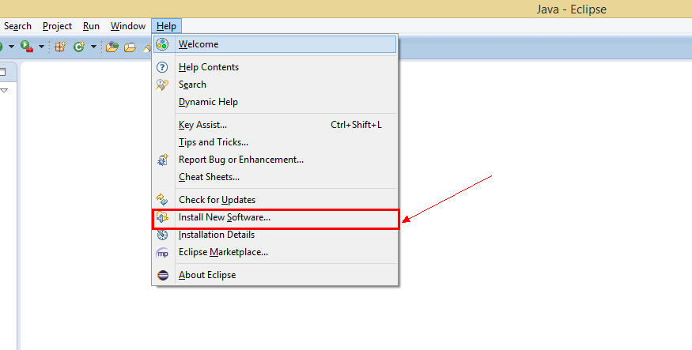

1. *You will see a dialog window, click “****Add****” button.*

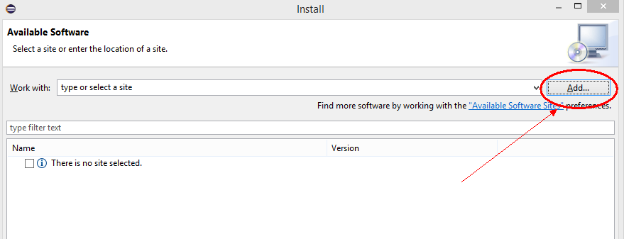

1. *Type name as you wish, let’s take “****Cucumber****” and type “****http://cucumber.github.com/cucumber-eclipse/update-site****” as location. Click* ***OK****.*

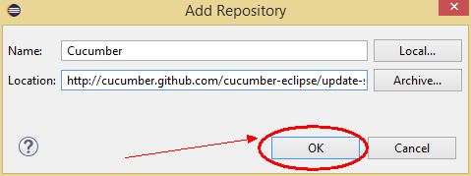

1. *You come back to the previous window but this time you must see* ***Cucumber Eclipse Plugin*** *option in the available software list. Just* ***Check*** *the box and press “****Next****” button.*

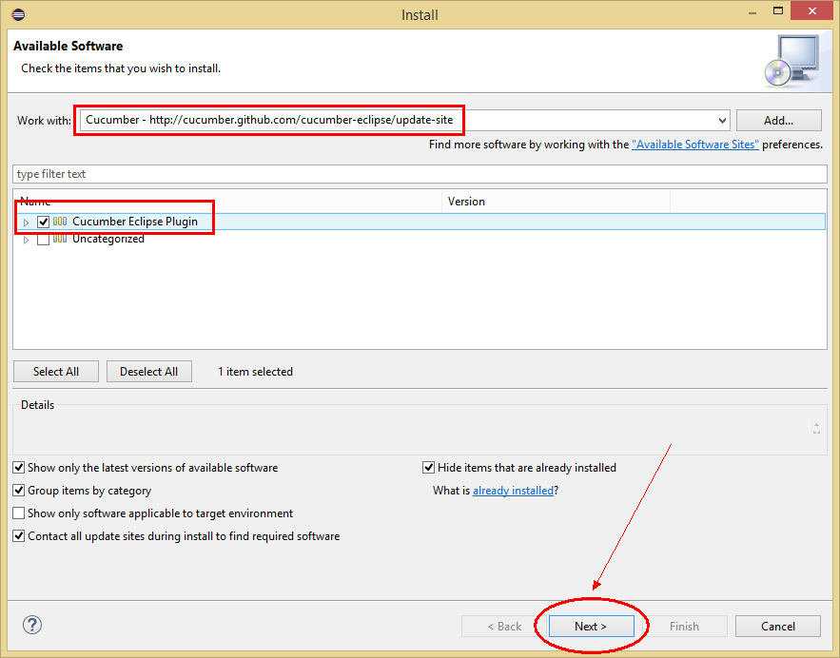

1. *Click on* ***Next****.*

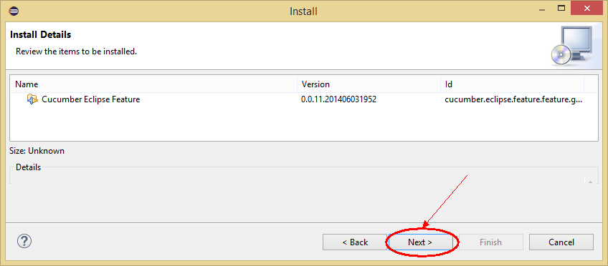

1. *Click “****I accept the terms of the license agreement****” then click* ***Finish****.*

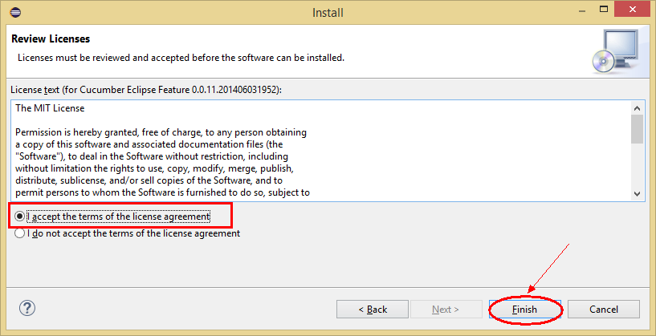

1. *Let it install, it will take few seconds to complete.*

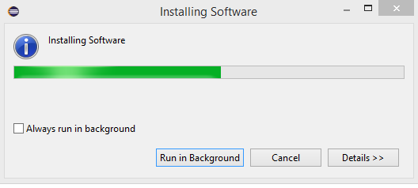

1. *You may or may not encounter a Security warning, if in case you do just click* ***OK****.*

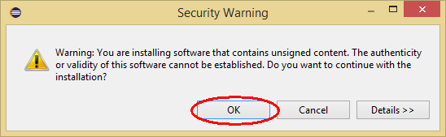

1. *You are all done now, just Click* ***Yes***

